

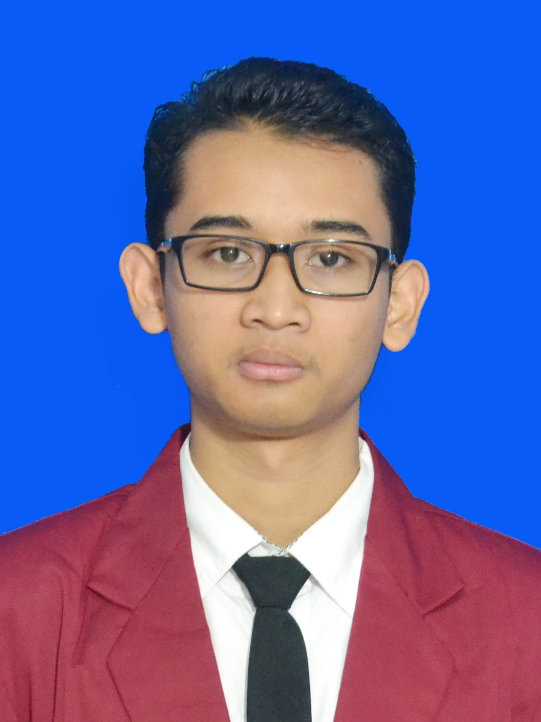
Nama : I Gede Arta Wiguna
NIM : 16101468
Jurusan : TM-MTI
Tugas : WEB 1

Hasil
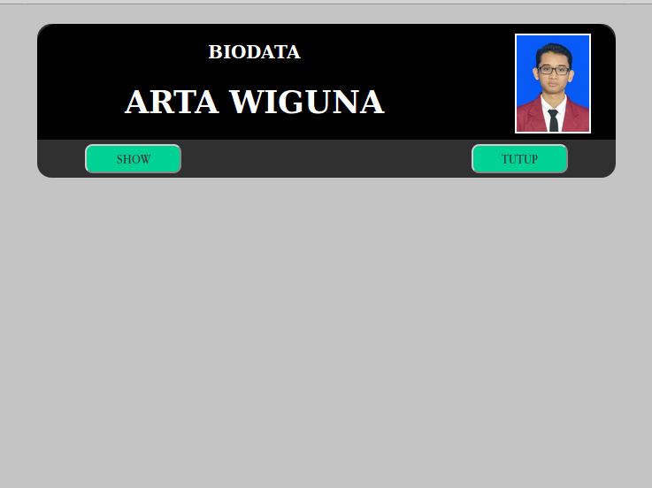

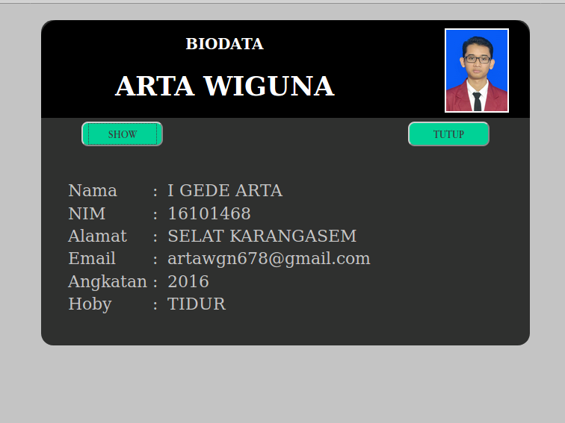

Syntax Program

File index.html
<!DOCTYPE html>
<html lang="en" dir="ltr">

<head>
<meta charset="utf-8">
<title>Tugas2 - WEB1</title>
<link rel="stylesheet" href="style.css">
<script src="jquery.js"></script>
</head>

<body>
<div id="kepala">
<div class="bungkus">
<div class="biodata">
<h3>BIODATA</h3>
<h1>ARTA WIGUNA</h1>
</div>
<div id="tempat-foto">
<img class="foto" src="gambar/16101468_arta_wiguna.jpeg">
</div>
<button id="tombol_buka" onclick="buka()">SHOW</button>
<button id="tombol_tutup">TUTUP</button>
</div>

<div id="data-diri">
<table border="0">
<tr>
<td width="100px">Nama </td>
<td>:</td>
<td id="nama"></td>
</tr>
<tr>
<td>NIM</td>
<td>:</td>
<td id="nim"></td>
</tr>
<tr>
<td>Alamat </td>
<td>:</td>
<td id="alamat"></td>
</tr>
<tr>
<td>Email </td>
<td>:</td>
<td id="email"> </td>
</tr>
<tr>
<td>Angkatan </td>
<td>:</td>
<td id="angkatan"></td>
</tr>
<tr>
<td>Hoby </td>
<td>:</td>
<td id="hoby"></td>
</tr>
</table>
</div>

</div>

<script>
//javascript
function buka() {
tampilkanData(
"i gede arta ",
16101468,
"Selat karangasem",
"artawgn678@gmail.com",
2016,
"Tidur");
document.getElementById("kepala").style.height = "400px";
}

function tampilkanData(p_nama, p_nim, p_alamat, p_email, p_angkatan, p_hoby) {
document.getElementById("nama").innerHTML = p_nama.toUpperCase();
document.getElementById("nim").innerHTML = p_nim;
document.getElementById("alamat").innerHTML = p_alamat.toUpperCase();
document.getElementById("email").innerHTML = p_email;
document.getElementById("angkatan").innerHTML = p_angkatan;
document.getElementById("hoby").innerHTML = p_hoby.toUpperCase();
}

//jQuery
$(document).ready(function() {
$("#tombol_tutup").click(function() {
$("#kepala").css("height", "160px");
});

});
</script>
</body>

</html>

File style.css

body {
background-color: rgb(196, 196, 196);
margin: 20px;
padding: 0;
}

#kepala {
background-color: rgb(47, 48, 47);
margin: 0 auto;
width: 600px;
height: 160px;
border-radius: 15px;
transition: 0.75s;
}

.bungkus {
display: grid;
grid-template-columns: repeat(2, auto);
}

.biodata {
background-color: rgb(26, 37, 27);
width: 450px;
height: 120px;
border-top-left-radius: 20px;
text-align: center;
background: black;
color: white;
}

h1,h3{
margin-left: 50px;
}

#tempat-foto {
background-color: yellow;
width: 150px;
height: 120px;
background: rgb(0, 0, 0);
color: white;
border-top-right-radius: 20px;
}

.foto {
width: 75px;
height: 100px;
padding: auto;
margin: 10px;
margin-left: 45px;
border: 2px solid ;
border-color: white;
}

#tombol_buka {
margin-top: 5px;
margin-left: 50px;
background-color: rgb(0, 210, 150);
width: 100px;
height: 30px;
border-radius: 8px;
}

#tombol_tutup {
margin-top: 5px;
background-color: rgb(0, 210, 150);
width: 100px;
height: 30px;
border-radius: 8px;
}

#data-diri{
width: 600px;
height: 300px;
color: rgb(196, 196, 196);
margin-left: 30px;
margin-top: 40px;
font-size: 25px;
}

table{
width: 600px;
font-size: 20px;
}

